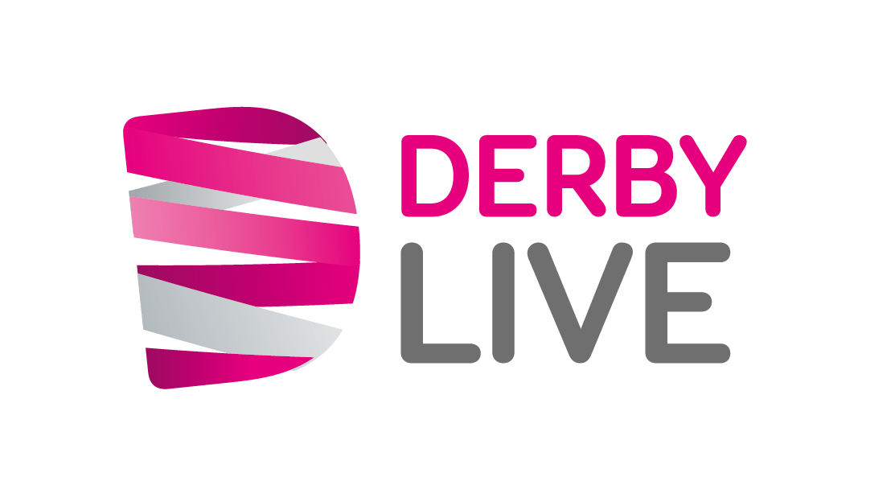
Application form to hire space in Derby City Centre

- Please read the Derby City Centre Space Hire - Terms and Conditions of use before you complete this form.
- Answer all relevant sections and provide copies of all required documents or your application may be delayed.
- Please print clearly when completing this form.
- When completed, please return this form to spacehire@derby.gov.uk.

Activity information

1. | Name of activity:
2. | Date(s) of activity:
3. | Start time of activity: |  |  |  |  |  |  |  |  | End time of activity:
4. | Site required: |  | (please refer to the pricing schedule for the hiring of space in Derby City Centre):
Hirer’s details (invoice will be sent to this address, please state full name and address of the company.)

5. | Hirer’s name:
Hiring Company/
organisation name:
 | Position:
 | Address:
 | Postcode:
 | Email:
 | Telephone: |  |  |  |  |  |  |  |  |  |  | Mobile:
 | Registered Charity number: |  | (if applicable)
6. | Is the hiring company/ organisation acting on behalf of another? If YES, please provide contact details below:
7. | Site contact details (this person will also be our main Health and Safety contact on the day)
 | Name:
 | Position:
 | Telephone: |  |  |  |  |  |  |  |  |  |  | Mobile:
 | Email:
Category of activity (please mark the appropriate box(s) with an X)
8. | Commercial/Promotional Campaign |  |  |  |  |  |  |  |  | Charity Collection/Stand*
 | Community Stand |  |  |  |  |  |  |  |  | Community Service Organisation Stand (e.g. army/police)
 | Religious Outreach/ Religious Service or Political Parties |  |  |  |  |  |  |  |  | Public Information Stand (Leafleting)
 | Fundraising |  |  |  |  |  |  |  |  | Market Research/Canvassers
 | Free Samples |  |  |  |  |  |  |  |  | Sales of Goods/Services
 | Other (please specify):
 | *if you are collecting money for a charity you will need to obtain the necessary permits and permissions. For more information, please email licensing@derby.gov.uk
9. | Please give a brief description of your activity:
Site information

10. | Type of equipment in use (please mark the appropriate box(s) with an X)
 | Detachable trailer (exhibition type) |  |  |  |  |  |  |  |  | Tent/gazebo
 | Exhibition vehicle (bus etc.) |  |  |  |  |  |  |  |  | Advert board/banners/flags etc.
 | Generator (silent type)* |  |  |  |  |  |  |  |  | Table top displays/flyers
 | Other (please specify):
 | *a current Generator Maintenance Certificate must be submitted.
11. | Overall dimensions of area needed for the activity:
 | Length |  |  | Width |  |  |  |  | Height |  |  |  |  |  |  | SQ Mt
12. | Will amplification equipment be used? If YES, please give description and the times of operation
 | Please give details:
 | Start time: |  |  |  |  |  |  |  | End time:
13. | Will any equipment be left on-site overnight? If YES, please give description and how long it will be left. (Prior authorisation must be gained from Derby LIVE as additional charges may be incurred.)
 | Please give details:
Electricity requirements

14. | Do you require access to electricity? If YES, please specify your requirements.*  (For further information, please see the price list)
 | Please give details:
 | *All electrical equipment must comply with point 17 of the Derby City Centre Space Hire - Terms and Conditions of Use.
Additional information or request

15. | Please give any additional information you think is relevant or list any additional requirements.
 | Please give details:
Costs and declaration

 | On receipt of this booking form, you will be informed of any fees due, please arrange payment by bacs, debit/credit card or request an invoice (please ensure that you quote the invoice number upon payment).
16. | Declaration (The person named as the “Hirer” on the application form must complete the section below.)
 | The information provided on this application is true and correct to the best of my knowledge.
 | I agree to comply with Derby City Centre Space Hire – Terms and Condition of Use.
 | I agree to pay the booking fee of £51.15 + VAT (£61.38).
 | I agree to pay the fee of |  |  |  |  | £ | for the hire/use of the space.
 | I have correctly completed the Indemnity Form Derby City Market Place and Public Highways.
I will ensure that the following documentation is attached/will be provided a minimum of 28 days prior to the activity taking place.

Please mark with an X:
 | Risk assessment
 | Copy of Public Liability Insurance
 | Electric (PAT) / Generator certificate (if applicable)
 | Signed:  The Hirer |  |  |  |  |  |  |  |  |  | Date:
INDEMNITY FORM
DERBY CITY MARKET PLACE AND PUBLIC HIGHWAYS
FORM OF INDEMNITY FOR THE EXECUTION OF PROMOTIONAL CAMPAIGNS, ENTERTAINMENT, OTHER EVENTS, WORKS AND OPERATIONS ON PROPERTY CONTROLLED BY DERBY CITY COUNCIL AND/OR MANAGED BY DERBY LIVE
PLEASE COMPLETE AND CLEARLY PRINT USING CAPITAL LETTERS
I |  | Name of Company,
 |  | Person or other body
of |  | Address (including postcode)

hereby indemnify Derby City Council, its officers, employees, agents and contractors against all claims against Derby City Council, its officers, employees, agents and contractors howsoever arising directly or indirectly from the execution by myself, my employees, agents and sub-contractors of works and operations and in particular
Type of activity to be held

at |  | Location where activity will be carried out (see map enclosed)

Date(s) |  | All inclusive
Time(s)

Name
Position
Signature*

*Status of Signatory (must be authorised, e.g.: if Limited Company signatory should be Director/Company Secretary)

PLEASE NOTE THAT IF A COMPLETED APPLICATION FORM, INDEMNITY FORM, A COPY OF A PUBLIC LIABILITY INSURANCE CERTIFICATE FOR A MINIMUM OF £5,000,000 AND A RISK ASSESSMENT ARE NOT RECEIVED BY DERBY LIVE AT MINIMUM OF 28 DAYS PRIOR TO THE ACTIVITY/PROMOTION, THE BOOKING WILL NOT BE CONFIRMED AND THE SITE RELEASED WITHOUT PRIOR NOTICE

THANK YOU

DERBY LIVE PRIVACY NOTICE
We collect your personal data when you make a booking/application or request information from us. This is in order to fulfil your booking/application; and to contact you about any important changes to your booking/application. Data may be shared with other selected organisations for health & safety reasons - a full list of these can be found in our privacy notice at www.derbylive.co.uk/yourprivacy, along with further information about how your personal information will be used. You can request a hard copy from inderby@derby.gov.uk.
Thank you for completing the application form, please return to:

Email: Spacehire@derby.gov.uk

Address: Outdoor Events and Spacehire
Derby LIVE
Guildhall Theatre
Market Place
Derby
DE1 3AE

Please note our Web and Social Media pages:

www.inderby.org.uk/events/whats-on/
www.derbylive.co.uk
https://twitter.com/derby_parks
https://www.facebook.com/DerbyParks/
https://www.facebook.com/InDerby/

